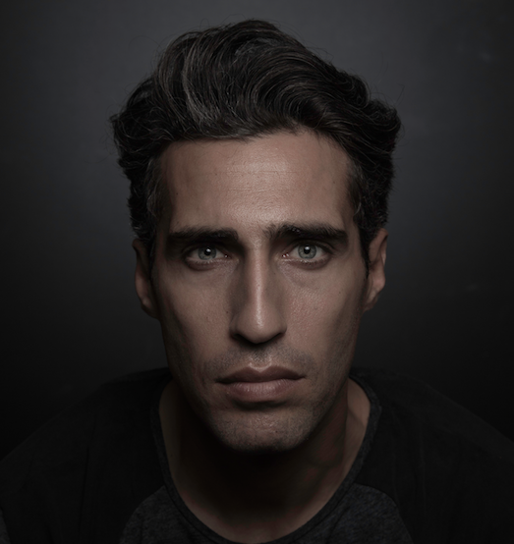

WORK EXPERIENCE
Film

The Promise | Conscription  officer | Terry George | Babieko Films

Theater
La estuardo  Keepers | Friedrich Schiller  Frederick Bailey | Nicolás Rivero  Valentina Calandriello | Nau Ivanow  Cotxeras Borell
Short films
Bus Stop  Sustancia X | Main Character  Main Charecter | Anuar Doss  Daniela Moreno | Afilm  Escac
Television
Teaser ¨Star¨ | Danny | Humberto Vignalia | Mister Garlic Productions
Scene work

Among others:  The Talented Tenth | Bernard | Javier Gálito-Cava | Anaglifos
Short Cuts | Ralph | Javier Gálito-Cava | Anaglifos
Two For The Seesaw | Jerry | Javier Gálito-Cava | Anaglifos

Education
Currently studying with Fernando Piernas in Madrid.
Graduated in Meisner Technique with Javier Galitó- Cava.
Two Trimesters of Mime at the Amsterdam school of arts.
Camera acting with Mel Churcher
Voice training in Wilfart method with Jon Del Vas And Linklater technique with Isabel Bres.
Stage Combat, bare hands and with weapons, with Valentina Calandriello.
Contemporary dance with Laura Vilar.
Theatre-dance with Mercedes Boronat.
Clown with Pedro Herrero and Félix Moreno.
Notes

Native speaker of English, dutch and spanish. Speech level of German and Catalan. And basic knowledge of Italian. High level in Stage combat and horseback riding.

